AUTOMATICALLY UPLOADING A FILE IN DYNAMODB FROM S3 BUCKET BY USING LAMBDA FUNCTION.

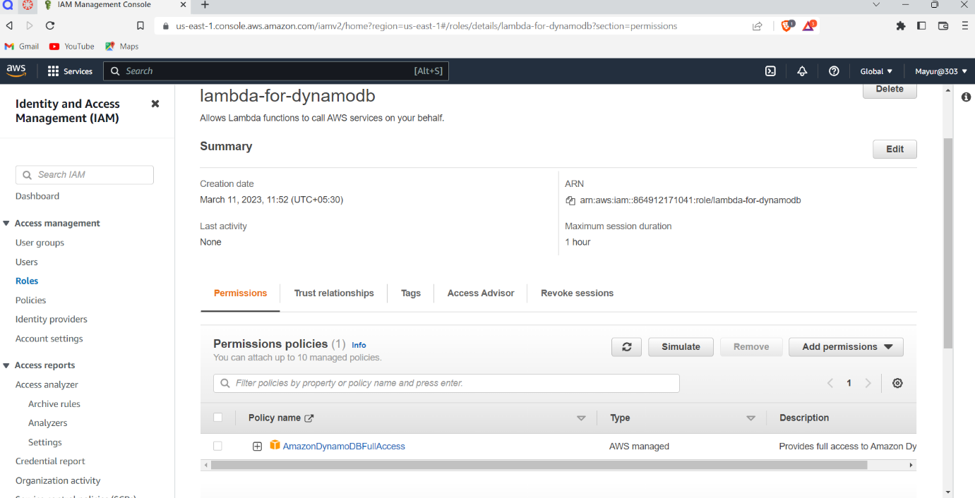

1. Creating a IAM Role for DynamoDB

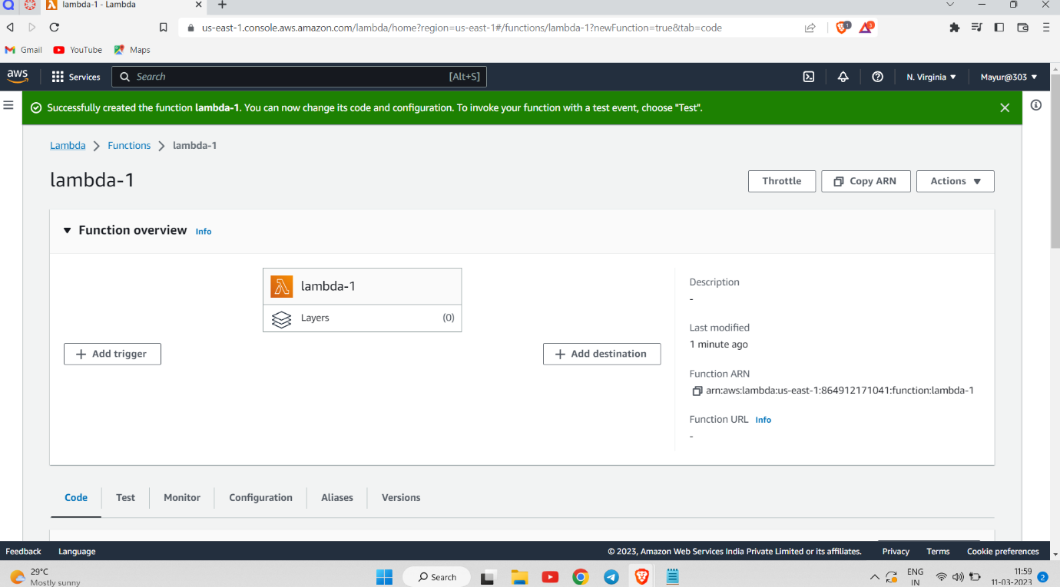

2. Creating a Lambda Function

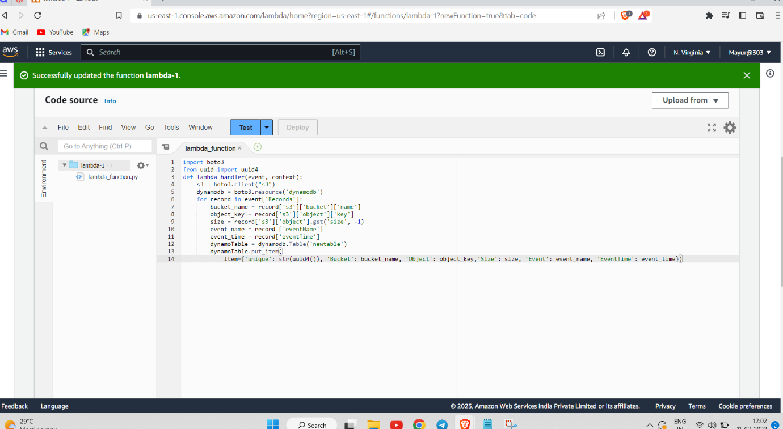

3. Updating Lambda Function and Adding the code.

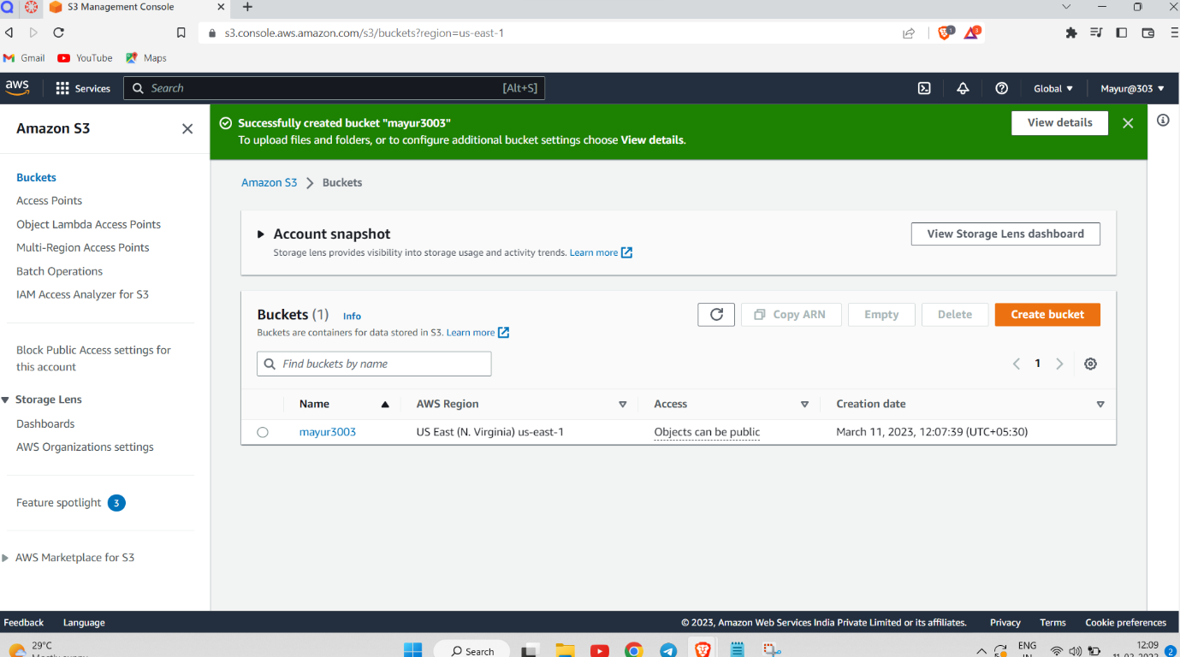

4. Creating a S3 Bucket

5.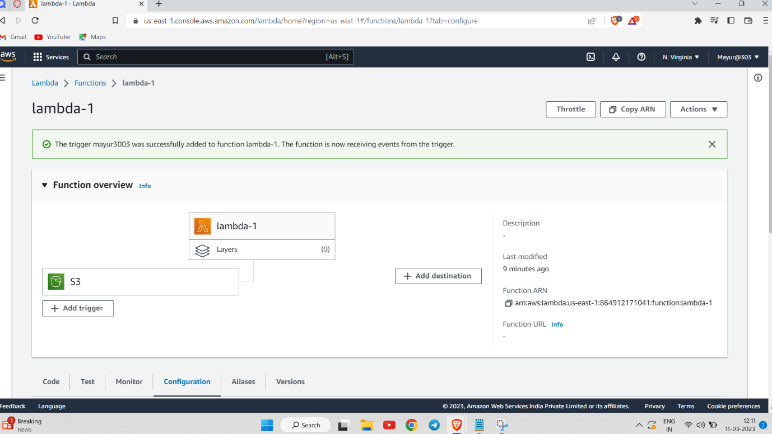

5. Adding a Trigger for S3 bucket in Lambda Function.

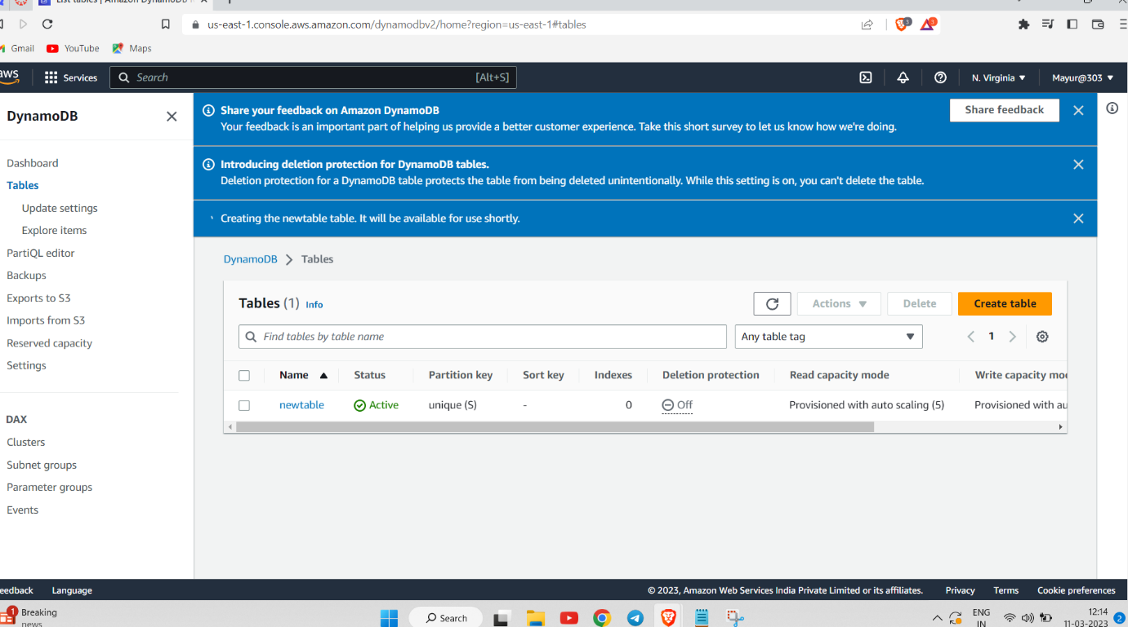

6.Creating a DynamoDB Table

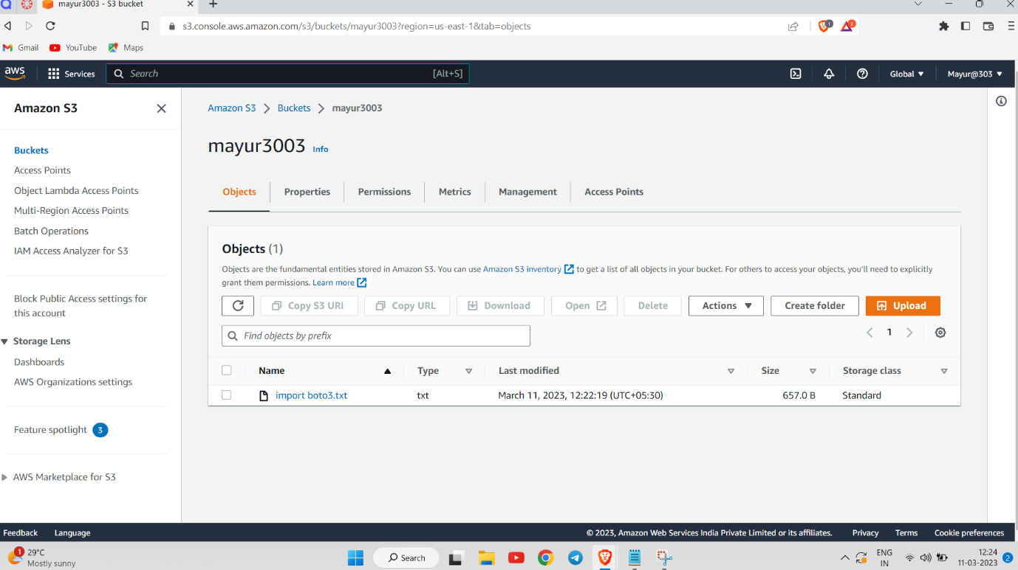

7. Uploading a file in S3 Bucket .

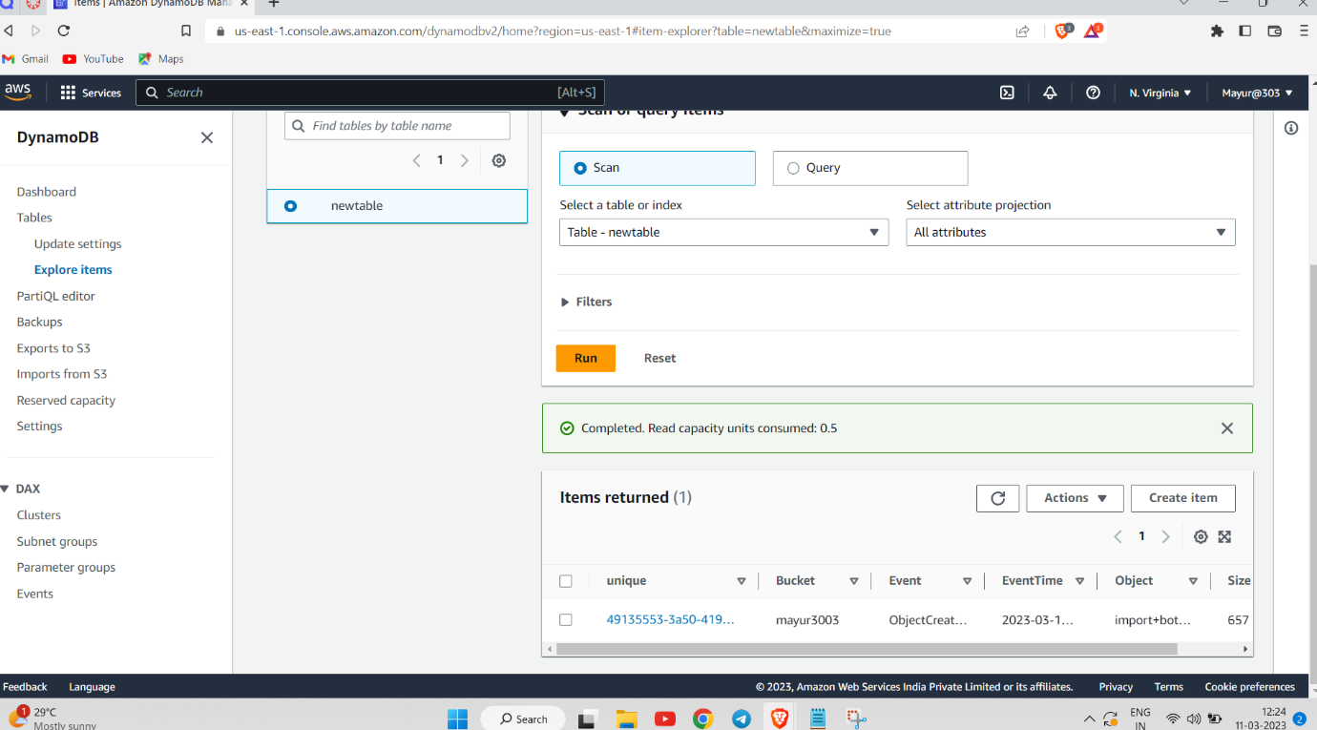

8. File is successfully added in dynamodb .